RELATIONSHIP BETWEEN FAMILY SUPPORT AND PSYCHOSOCIAL PROBLEMS IN DIABETES MELLITUS PATIENTS AT GARUDA HEALTH CENTER PEKANBARU CITY

Wyana Syehrika Dea Safitri^{1*}, Emul Yani², Yeni Devita², M. Zul’irfan²
1 Program Studi of Profesi Ners, Faculty of Nursing, Institus Kesehatan Payung Negeri, Pekanbaru, Indonesia
*Corresponding author: wyanasyehrika@gmail.com

Abstract
Diabetes Mellitus (DM) patients experience various adverse psychological reactions as a result of sudden changes in their lives, with excessive worry being one of them. So that psychosocial support is needed to increase family support in Diabetes Mellitus patients. This study aims to determine the relationship between family support and psychosocial problems in diabetes mellitus patients at Garuda Health Center, Pekanbaru City. This type of research uses a quantitative design with a correlation design using a cross-sectional approach. The research sample consisted of 54 respondents selected using the accidental sampling technique. The instruments used were the Hensarling Diabetes Family Support Scale (HDFSS) questionnaire to measure family support and the Depression Anxiety Stress Scales (DASS 42) questionnaire to measure levels of depression, stress, and anxiety. The results of the Chi-Square statistical test showed that there was a significant relationship between family support and psychosocial problems in DM patients, with a p-value of 0.000 (p <0.05). This study is expected that health centers can provide education to families to provide emotional, appreciation, instrumental, and informational support to diabetes patients and further researchers to modify the instrument so that the results are better.

Keyword: Family Support, Psychosocial Problems, Diabetes Mellitus

INTRODUCTION
Diabetes mellitus is a non-communicable disease whose cases are experiencing a significant increase worldwide. The International Diabetes Federation (IDF) reports that the number of diabetes sufferers reached 537 million in 2021 and is expected to increase to 783 million by 2045. Indonesia is among the top five countries with the highest number of diabetes sufferers, with the number of cases predicted to increase from 19.5 million in 2021 to 28.6 million in 2045. In Riau Province, the number of diabetes sufferers reached 50,424 cases, while in Pekanbaru City, cases of diabetes mellitus reached 19,587 in 2023, with the Garuda Community Health Center (Puskesmas) as the health facility with the highest number of cases, with 1,848 cases.
Diabetes mellitus is characterized by elevated blood glucose levels due to impaired insulin production or function, which can lead to short-term and long-term complications if not properly managed. In addition to physical impacts, diabetes also affects the patient's psychosocial well-being. People with diabetes often experience stress, anxiety, and depression due to the lengthy, expensive management of the disease, and the lifestyle changes required. This can reduce quality of life and medication adherence, ultimately worsening the patient's health.
Psychosocial support is crucial in helping patients with diabetes cope with the emotional and social challenges that arise from this disease. However, research shows that only 48.8% of patients with diabetes receive psychosocial support from healthcare professionals due to various constraints such as limited time, workload, and lack of family involvement in patient care. In this regard, family support is a crucial factor in helping patients manage diabetes mellitus. Family support encompasses emotional, appreciative, informational, and instrumental aspects that can help patients feel more comfortable, motivated, and more adhere to treatment and a healthy lifestyle.
Research conducted by Hidayatul Rahmi, Hema Malini, and Emil Huriani, 2020. "The Role of Family Support in Reducing Diabetes Distress in Diabetes Mellitus Patients." This study design was quasi-experimental with a pre- and post-test control group. Simple random sampling was used to select 64 participants (32 per group). Data were collected using the Diabetes Distress Scale (DDS-17). Results: Data analysis using the Wilcoxon test showed an effect of family support on Diabetes Distress (p=0.000).
Preliminary study results indicate that most diabetes mellitus patients experience psychosocial problems such as anxiety, excessive sadness, and loss of interest in activities. Some patients reported receiving attention, advice, and financial assistance from their families, but still felt unmotivated to live a healthy lifestyle. Based on this background, this study aims to analyze the relationship between family support and psychosocial problems in diabetes mellitus patients at the Garuda Community Health Center in Pekanbaru City.

RESEARCH METHOD
This research is a quantitative descriptive study with a correlation design and a cross-sectional approach. In this design, the researcher emphasized the measurement or observation time of independent and dependent variable data only once at a time. The population in this study were all Diabetes Mellitus patients who visited the Garuda Community Health Center in Pekanbaru City. The sampling technique used was purposeful accidental sampling. The instruments used were the Hensarling Diabetes Family Support Scale (HDFSS) questionnaire to measure family support and the Depression Anxiety Stress Scales (DASS) questionnaire to measure psychosocial problems.

RESEARCH RESULTS
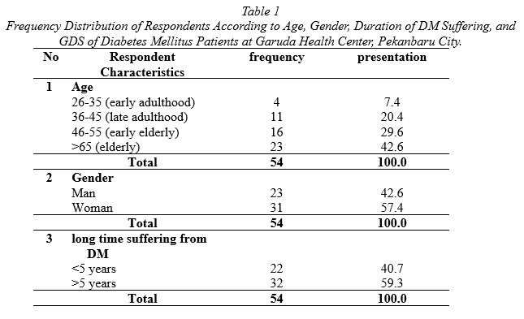
Source: Primary Data

Table 1 shows that the majority of respondents were in the age group >65 years (42.6%), followed by the age groups 46-55 years (29.6%), 36-45 years (20.4%), and 26-35 years (7.4%). Based on gender, more respondents were female (57.4%) than male (42.6%). In terms of duration of diabetes mellitus (DM), most had suffered from this disease for more than 5 years (59.3%), while the rest had suffered from it for less than 5 years (40.7%).
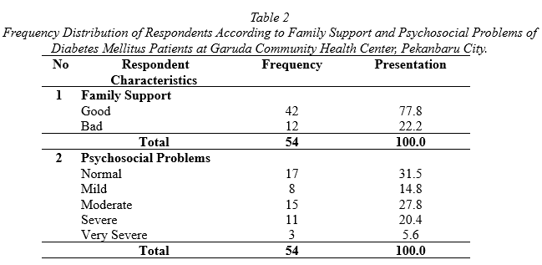
Source: Primary Data

Table 2 shows that the majority of respondents received good family support (77.8%), while 22.2% experienced poor family support. In terms of psychosocial problems, the majority of respondents were in the normal category (31.5%), followed by moderate (27.8%), mild (14.8%), severe (20.4%), and very severe (5.6%).
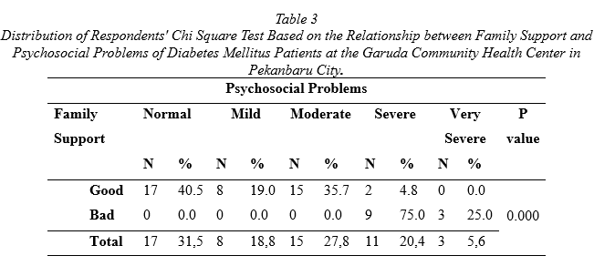
Source: Primary Data

Table 3 Chi-square test results indicate a significant relationship between family support and psychosocial problems in diabetes mellitus patients. Data analysis revealed that the majority of respondents with good family support fell into the normal (40.5%), moderate (35.7%), and mild (19.0%) psychosocial problem categories. Meanwhile, only 4.8% experienced severe psychosocial problems, and none fell into the very severe category (0.0%). Conversely, respondents with poor family support tended to experience more severe psychosocial problems. 75.0% of them fell into the severe category, and 25.0% fell into the very severe category. No respondents with poor family support fell into the normal, mild, or moderate categories.
The analysis showed a p-value of 0.000, indicating a highly significant relationship (p < 0.05). This means that the better the family support received by diabetes mellitus patients, the lower their likelihood of experiencing severe psychosocial problems. These results emphasize the importance of the family's role in supporting patients' psychological well-being in managing their disease.

DISCUSSION
Univariate Analysis
The study results showed that the majority of respondents with Diabetes Mellitus (DM) were in the elderly age group (>65 years), at 42.6%. According to PERKENI (2021), age is a non-modifiable risk factor for the development of DM, especially for individuals over 40 years of age. With age, insulin sensitivity in the body decreases, leading to increased blood sugar levels and the risk of complications such as diabetic neuropathy, retinopathy, and cardiovascular disease. This finding is supported by research conducted by Wang et al. (2021), which found that older adults have a higher risk of insulin resistance than younger age groups. Furthermore, research conducted by Ashraff et al. (2022) showed that older individuals with DM are more susceptible to psychosocial problems such as stress and anxiety due to disease complications and the lifestyle changes they must undergo. This study reveals that family support and psychosocial interventions are crucial in helping elderly patients manage their disease more effectively.
The study results showed a gender distribution of respondents, with women suffering from diabetes mellitus (DM) more often than men, with proportions of 57.4% and 42.6%, respectively. This indicates that women are more susceptible to diabetes than men. According to research conducted by Muliawaty & Hendryawan (2020), women have a higher risk of developing type 2 diabetes than men due to hormonal factors and metabolic changes due to menopause, which can lead to insulin resistance. Furthermore, research by Bachmeier et al. (2020) revealed that women with diabetes more frequently experience psychosocial disorders, such as stress and anxiety, which are related to disease management and long-term complications.
The study results showed a distribution of respondents based on the duration of diabetes mellitus (DM), with the majority (59.3%) having had diabetes for more than 5 years. According to research by Bachmeier et al. (2020), the longer a person has diabetes, the greater the likelihood of developing macrovascular complications (such as heart disease and stroke) and microvascular complications (such as retinopathy, neuropathy, and nephropathy). This aligns with the findings of PERKENI (2021), which stated that patients with DM duration of more than 5 years tend to experience decreased metabolic function and increasingly difficult glycemic control. Furthermore, research conducted by Hidayah (2019) showed that DM patients who have suffered from the disease for a long time often experience stress and mental fatigue due to the burden of continuous disease management. This can impact patient adherence to therapy and a healthy lifestyle, increasing the risk of further complications.

Bivariate Analysis
The results of the study showed a chi-square test for the relationship between family support and psychosocial problems in patients with diabetes mellitus (DM) at the Garuda Community Health Center in Pekanbaru City. The analysis showed that the majority of respondents with good family support fell into the normal (40.5%), moderate (35.7%), and mild (19.0%) psychosocial categories. Meanwhile, only 4.8% experienced severe psychosocial problems, and none fell into the very severe category (0.0%). Conversely, patients with poor family support experienced more severe psychosocial problems, with 75.0% falling into the severe category and 25.0% into the very severe category. No patients fell into the normal, mild, or moderate categories.
The statistical analysis showed a p-value of 0.000, indicating a significant relationship between family support and psychosocial problems in DM patients. The better the family support received, the lower the risk of patients experiencing severe psychosocial problems. This indicates that family support plays a crucial role in the emotional stability and quality of life of DM patients.
According to research conducted by Hidayah (2019), diabetes patients often experience stress, anxiety, and depression due to lifestyle changes and uncertainty related to disease complications. Prolonged stress can increase cortisol levels in the body, ultimately worsening blood sugar control and increasing the risk of diabetes complications.
Wahyuni ​​et al. (2023) also found that patients without adequate family support tend to experience higher levels of emotional distress, which negatively impacts adherence to treatment and disease management. Furthermore, Juli et al. (2024) revealed that only 48.8% of diabetes patients receive adequate psychological support. This low level of support contributes to increased anxiety and emotional instability in patients.
Family support not only plays a role in emotional aspects but also influences patient adherence to therapy and adopting a healthy lifestyle. Research conducted by Priharsiwi & Kurniawati (2021) showed that patients with family support are more disciplined in managing their diet, exercise, and adherence to health check-up schedules. Furthermore, Hidayatul Rahmi et al. (2020) found that strong family support contributed to reducing diabetes distress in patients, which ultimately positively impacted quality of life and treatment success.
Based on these findings, researchers assume that family support plays a crucial role in helping patients cope with the psychosocial stress of diabetes. Patients who receive family support tend to be better able to manage their emotions, adhere to treatment, and maintain a healthy lifestyle, thereby reducing the risk of complications. Therefore, family-based interventions in the care of diabetes patients are essential. Family education programs, psychological support, and social support can be effective strategies to enhance patient well-being and improve treatment outcomes.

CONCLUSION
This study aims to analyze the relationship between family support and psychosocial problems in diabetes mellitus patients at the Garuda Community Health Center in Pekanbaru City. A significant relationship was found between family support and psychosocial problems in diabetes mellitus patients at the Garuda Community Health Center in Pekanbaru City (p=0.000 (p<0.05).

REFERENCE
Alfatih, H., Faishal, & Irawan, E. (2021). Factors Affecting the Quality of Life of Type II Diabetes Mellitus Patients at Babakan Sari Community Health Center. BSI Nursing Journal, 9(1), 74–81. http://ejurnal.ars.ac.id/index.php/keperawatan/article/view/483
Ashraff, S., Siddiqui, M. A., & Oman, T. E. C. (2022). Oman Medical Specialty Board: The Psychosocial Impact of Diabetes in Adolescents: A Review. Medical Journal, 28(3), 159–162. http://publications.nice.org.uk/type-1-diabetes-cg15
Asiimwe, D., Mauti, G. O., & Kiconco, R. (2020). Prevalence and Risk Factors Associated with Type 2 Diabetes in Elderly Patients Aged 45-80 Years in Kanungu District. Journal of Diabetes Research, 2020. https://doi.org/10.1155/2020/5152146
Febriani, R. P., Prabowo, N. A., Putri, D. P., & Setyawan, S. (2023). Diabetes Guide for Patients and Families.
Firmansyah, D., & Dede. (2022). General Sampling Techniques in Methodology. Scientific Journal of Holistic Education (JIPH), 1(2), 85–114.
Hafni, S. Y., Deli, H., & Erwin, E. (2024). Overview of Psychosocial Problems in Patients with Diabetes Mellitus in the Inpatient Ward. JERUMI: Journal of Education, Religion, Humanities, and Multidisciplinary, 2(1), 229–235. https://doi.org/10.57235/jerumi.v2i1.1819
Haiya, N. N., & Ardian, I. (2020). The Relationship Between Family Support and Ability Level. The 2nd Unissula Nursing Conference (UNC) Sultan Agung Islamic University, 66–70.
Hidayah, N. (2019). The Relationship Between Nurses' Psychosocial Support and the Quality of Life of Type 2 Diabetes Mellitus Patients at Sultan Syarif Mohamad Alkadrie General Hospital, Pontianak City. Proners, 4(1), 1–11. https://dx.doi.org/10.26418/jpn.v4i1.33516
Juli, V. N., Solehati, F., Sasmiyanto, S., Adi, G. S., Jl, A., & No, K. (2024). The Relationship between Psychosocial Support and the Gangrenous Wound Healing Process in Type 2 Diabetes Mellitus Patients at the Ibnu Sina Sejahtera Jenggawah Clinic, Muhammadiyah University of Jember, East Java Province, Indonesia. Reports the number of diabetes sufferers aged , f. 2(3).
PERKENI, 2021. (2021). Guidelines for the Management and Prevention of Type 2 Diabetes Mellitus in Adults in Indonesia 2021. In Global Initiative for Asthma.
Priharsiwi, D., & Kurniawati, T. (2021). Overview of Family Support and Diet Compliance in Type 2 Diabetes Mellitus Patients: Literature Review. Proceedings of the National Health Seminar, 1, 324–335. https://doi.org/10.48144/prosiding.v1i.679
Putra, G. J. (2019). Family Support Book for Diabetic Foot Ulcer Patients (pp. 12–16).
Riyadi, A., & Khoiroh Muflihatin, S. (2021). The Relationship Between Family Support and Self-Management in Type II Diabetes Mellitus Patients in the Palaran Community Health Center Work Area, Samarinda City. Borneo Student Research, 2(2), 1010–1016.
Wahyuni, A. N., Suhanda, S., & Supriadi, D. (2023). A Case Study of Psychosocial Status in Families of Diabetes Mellitus Patients. Indogenius, 2(2), 88–93. https://doi.org/10.56359/igj.v2i2.255

